**A**

**Mini Project Report**

**On Shoe Store Management**

By

**P Surya Shiva Charan Reddy 1602-21-733-124**

**P Vishroth Reddy 1602-21-733-134**



**Department of Computer Science & Engineering**

**Vasavi College of Engineering**

**(Autonomous)**

**(Approved by A.I.C.T.E)**

**9-5-81, Ibrahimbagh, Hyderabad-31**

**2023**

**ACKNOWLEDGEMENT**

We are deeply grateful to take this opportunity to thank our mentor and our honored guide, **Dr. V. Sireesha,** Department of Computer Science and Engineering, whose guidance is always upgrading the scalability of the projects that we are making on. Her innovative ideas added to our project, impactful suggestions, and motivation to innovate newer, bigger projects made us develop this project with a vision to solve the problems of people suffering along with me.

We are grateful to **Dr.T. Adilakshmi,** the HOD of Computer Science and Engineering department, Vasavi College of Engineering for the help during our course work.

Finally, we express thankfulness to the management of Vasavi College of Engineering for cooperating with us while doing this project.

**TABLE OF CONTENTS**

List of figures…………………………………………………………………………..

1. Abstract………………………………………………………………………………….1

2. Introduction……………………………………………………………………………2

3. SRS………………………………………………………………………………………….4

4. Code ……………………………………………………………………………………….5

5. Result …………………………………………………………………………………….21

6. References………………………………………………………………………………24

**LIST OF FIGURES**

1. Figure 1. Main page………………..21
2. Figure 2. Store page………………..22
3. Figure 3. Retrieve page …………..22
4. Figure 4. Shoe store………………...23

**1.ABSTRACT**

The shoe store management project aims to develop an online platform for managing a shoe store's inventory and facilitating customer search and purchase activities. The project includes the development of a web-based application that allows users to search for available shoe models and sizes, add items to their cart, and view their cart contents. The system is built using PHP and MySQL for database management. It provides a user-friendly interface for customers to easily navigate and find their desired shoes. The project also incorporates features for inventory management, ensuring real-time availability updates for each shoe model and size.

**2. INTRODUCTION**

The shoe store management project is designed to streamline the operations of a shoe store and enhance the customer shopping experience. The system consists of three main components: the online store, the shoe data storage and retrieval module, and the shopping cart functionality.

The online store, implemented in onlinestore.php, serves as the entry point for customers. It provides a visually appealing interface where users can search for shoe models by entering the shoe name and size. The search query is processed through a PHP script that connects to a MySQL database and retrieves the availability information for the requested shoe model and size. The result is displayed to the user, indicating the number of shoes available.

The shoe data storage and retrieval module, implemented in store4.php, handles the database operations. It establishes a connection to the MySQL database and inserts new entries into the "availability" table, representing the availability of shoes by model and size. Input validation is performed to ensure that only valid data is stored in the database. If an invalid size is entered, an appropriate error message is displayed to the user.

The shopping cart functionality, implemented in cart.html, allows users to add selected items to their cart and view the contents of the cart. By clicking the "Add to Cart" button, the selected shoe item is added to the cart displayed on the webpage. The cart can be cleared, removing all items from it.

**3.SYSTEM REQUIREMENTS**

Web Server: The system requires a web server with PHP support to run the PHP scripts.

Database: A MySQL database is needed to store and retrieve shoe availability data.

PHP: The server must have PHP installed and properly configured.

Browser Support: The system is designed to be accessed through modern web browsers, ensuring compatibility with HTML, CSS, and JavaScript.

Internet Connection: An internet connection is required to access the online store and perform search and purchase activities.

Suitable Hardware: The system can run on standard hardware configurations, including a computer or server with sufficient processing power and memory to handle web traffic and database operations efficiently.

By implementing this shoe store management system, the store can effectively manage its inventory, provide accurate availability information to customers, and offer a seamless online shopping experience.

**4.CODE**

**Main code:**

<!DOCTYPE html>

<html>

<head>

  <title>Shoe Search Website</title>

  <style>

    body {

      font-family: Arial, sans-serif;

      margin: 0;

      padding: 0;

    }

    body {

      background-image: url('https://wallpaperaccess.com/full/680075.jpg');

      background-repeat: no-repeat;

      background-size: 100% 100%;

      background-position: center;

    }

    .container {

      display: flex;

      flex-direction: column;

      align-items: flex-end;

      justify-content: center;

      height: 100vh;

      padding: 20px;

      color: #259306;

      text-align: right;

    }

    .text {

      font-size: 2rem;

      line-height: 1.5;

    }

    .text::before {

      content: ' ';

      position: absolute;

      top: 0;

      left: 0;

      width: 100%;

      height: 100%;

      background: radial-gradient(circle, #04ea92 5%, transparent 20%);

      transform: scale(10);

      opacity: 0.1;

      z-index: -1;

      animation: pulsateAnimation 2s ease-in-out infinite;

    }

    @keyframes pulsateAnimation {

      0% { transform: scale(1); opacity: 0.1; }

      50% { transform: scale(10); opacity: 0.01; }

      100% { transform: scale(1); opacity: 0.1; }

    }

    .button {

      margin-top: 20px;

      padding: 10px 20px;

      font-size: 1rem;

      background-color: #259306;

      color: #fff;

      border: none;

      border-radius: 4px;

      cursor: pointer;

    }

  </style>

</head>

<body>

  <div class="container">

    <div class="text">

      LOVE<br>

      THE<br>

      PLANET<br>

      WE WALK ON

      <div>

        <button class="button" onclick="redirectToOtherWebsite()">Check Availability</button>

        <button class="button" onclick="redirectToStoreWebsite()">Store</button>

        <button class="button" onclick="redirectToStoreWebsite2()">Online Store</button>

      </div>

  <script>

   function redirectToOtherWebsite() {

      window.location.href = "onlineshoe.php";

    }

    function redirectToStoreWebsite() {

      window.location.href = "store4.php";

    }

    function redirectToStoreWebsite2() {

      window.location.href = "cart.html";

    }

  </script>

</body>

</html>

**Store code:**

<?php

$insert = false;

if(isset($_POST['model'])){

    // Set connection variables

    $server = "localhost";

    $username = "root";

    $password = "";

    // Create a database connection

    $con = mysqli_connect($server, $username, $password);

    if(!$con){

        die("connection to this database failed due to" . mysqli_connect_error());

    }

    $result=mysqli_query($con,"SELECT count(*) FROM `shoeStore`.`availability` where `model`='$_POST[model]' and `size`='$_POST[size]'");

    $row=mysqli_fetch_array($result);

    $insert=true;

  }

  ?>

<!DOCTYPE html>

<html>

<head>

  <title>Shoe Search Website</title>

  <style>

    body {

      font-family: Arial, sans-serif;

      margin: 0;

      padding: 0;

    }

    body {

      background-image: url('https://c0.wallpaperflare.com/preview/186/124/897/red-and-white-air-jordan-1-shoe-on-concrete-floor.jpg');

      background-repeat: no-repeat;

      background-size: cover;

      background-position: center;

    }

    .container {

      display: flex;

      flex-direction: column;

      align-items: center;

      justify-content: center;

      height: 100vh;

      padding: 20px;

      color: #fff;

      text-align: center;

    }

    .header {

      font-size: 3rem;

      margin-bottom: 20px;

    }

    .header span {

      color: #4CAF50;

      font-weight: bold;

    }

    .search-bar {

      margin-top: 20px;

    }

    .search-bar input[type="text"],

    .search-bar input[type="number"],

    .search-bar input[type="submit"] {

      padding: 12px 20px;

      font-size: 1rem;

    }

    .search-bar input[type="text"],

    .search-bar input[type="number"] {

      width: 300px;

      border: none;

      border-radius: 5px;

      margin-right: 10px;

    }

    .search-bar input[type="submit"] {

      background-color: #4CAF50;

      color: #fff;

      border: none;

      border-radius: 5px;

      cursor: pointer;

      transition: background-color 0.3s ease-in-out;

    }

    .search-bar input[type="submit"]:hover {

      background-color: #45a049;

    }

  </style>

</head>

<body>

  <div class="container">

    <h1 class="header">

      Find Your Perfect <span>Shoe</span>

    </h1>

    <div class="search-bar">

      <form action="onlineshoe.php" method="post">

        <input type="text" id="model" name="model" placeholder="Enter shoe name">

        <input type="number" id="size" name="size" placeholder="Enter shoe number" style="width: 300px;">

        <input type="submit" value="Search">

      </form>

    </div>

    <?php

    if($insert==true){

      echo "<h3 class='header'>

The no of shoes <span>available: $row[0]</span>

</h3>";

    }

    ?>

  </div>

</body>

</html>

**Retrieve code:**

<?php

$insert = false;

$invalid = false;

if(isset($_POST['model'])){

    // Set connection variables

    $server = "localhost";

    $username = "root";

    $password = "";

    // Create a database connection

    $con = mysqli_connect($server, $username, $password);

    // Check for connection success

    if(!$con){

        die("connection to this database failed due to" . mysqli_connect_error());

    }

    // echo "Success connecting to the db";

    // Collect post variables

    $model = $_POST['model'];

    $size = $_POST['size'];

    if($size>0)

    {

      $sql = "INSERT INTO `shoeStore`.`availability` (`model`, `size`) VALUES ('$model', '$size');";

    // Execute the query

    if($con->query($sql) == true){

        // echo "Successfully inserted";

        $insert = true;

    }

    else{

        echo "ERROR: $sql <br> $con->error";

    }

    }

    else{

      $invalid=true;

    }

    // Close the database connection

    $con->close();

}

?>

<!DOCTYPE html>

<html>

<head>

  <title>Shoe Search Website</title>

  <style>

    body {

      font-family: Arial, sans-serif;

      margin: 0;

      padding: 0;

    }

    body {

      background-image: url('https://wallpaperaccess.com/full/1597753.jpg');

      background-repeat: no-repeat;

      background-size: cover;

      background-position: center;

    }

    .container {

      display: flex;

      flex-direction: column;

      align-items: center;

      justify-content: center;

      height: 100vh;

      padding: 20px;

      color: #fff;

      text-align: center;

    }

    .header {

      font-size: 3rem;

      margin-bottom: 20px;

    }

    .header span {

      color: #4CAF50;

      font-weight: bold;

    }

    .search-bar {

      margin-top: 20px;

    }

    .search-bar input[type="text"],

    .search-bar input[type="number"],

    .search-bar input[type="submit"] {

      padding: 12px 20px;

      font-size: 1rem;

    }

    .search-bar input[type="text"],

    .search-bar input[type="number"] {

      width: 300px;

      border: none;

      border-radius: 5px;

      margin-right: 10px;

    }

    .search-bar input[type="submit"] {

      background-color: #4CAF50;

      color: #fff;

      border: none;

      border-radius: 5px;

      cursor: pointer;

      transition: background-color 0.3s ease-in-out;

    }

    .search-bar input[type="submit"]:hover {

      background-color: #45a049;

    }

  </style>

</head>

<body>

  <div class="container">

    <h1 class="header">

      Enter the <span>data</span>

    </h1>

    <div class="search-bar">

      <form action="store4.php" method="post">

        <input type="text" id="model" name="model" placeholder="Enter shoe name">

        <input type="number" id="size" name="size" placeholder="Enter shoe number" style="width: 300px;">

        <input type="submit" value="Search">

      </form>

      <?php

    if($insert==true){

      echo "<h3 class='header'>

<span>done!</span>

</h3>";

    }

    else if($invalid==true){

      echo "<h3 class='header'>

<span>Invalid input!</span>

</h3>";

    }

      ?>

    </div>

  </div>

</body>

</html>

**Online store:**

<!DOCTYPE html>

<html>

<head>

  <title>Shoe Store</title>

  <style>

    body {

      font-family: Arial, sans-serif;

      background-image: url('https://images.pexels.com/photos/19090/pexels-photo.jpg?cs=srgb&dl=pexels-web-donut-19090.jpg&fm=jpg');

      background-repeat: no-repeat;

      background-size: cover;

      background-position: center;

    }

    h1 {

      text-align: center;

      color: #fff;

      margin-top: 40px;

      text-shadow: 2px 2px 4px rgba(0, 0, 0, 0.5);

    }

    .shoe-container {

      display: grid;

      grid-template-columns: repeat(auto-fit, minmax(300px, 1fr));

      gap: 20px;

      justify-items: center;

      margin: 40px;

    }

    .shoe-item {

      display: flex;

      flex-direction: column;

      align-items: center;

      padding: 10px;

      background-color: rgba(255, 255, 255, 0.8);

      box-shadow: 0 2px 4px rgba(0, 0, 0, 0.1);

      border-radius: 4px;

      transition: transform 0.3s ease;

    }

    .shoe-item:hover {

      transform: scale(1.05);

    }

    .shoe-image {

      width: 200px;

      height: 200px;

      border-radius: 4px;

      transition: transform 0.3s ease;

    }

    .shoe-item:hover .shoe-image {

      transform: scale(1.1);

    }

    .shoe-item span {

      font-weight: bold;

      color: #333;

      margin-top: 10px;

      text-align: center;

    }

    .shoe-item button {

      background-color: #4caf50;

      color: #fff;

      border: none;

      padding: 5px 10px;

      margin-top: 10px;

      cursor: pointer;

      border-radius: 4px;

      transition: background-color 0.3s ease;

      animation: pulse 1.5s infinite;

    }

    .shoe-item button:hover {

      background-color: #45a049;

      animation: none;

    }

    .cart {

      border: 1px solid #ccc;

      padding: 10px;

      background-color: rgba(255, 255, 255, 0.8);

      box-shadow: 0 2px 4px rgba(0, 0, 0, 0.1);

      border-radius: 4px;

      transition: transform 0.3s ease;

      margin: 40px;

      max-width: 400px;

      margin-left: auto;

      margin-right: auto;

    }

    .cart:hover {

      transform: scale(1.05);

    }

    .cart h2 {

      margin-top: 0;

      color: #333;

      text-align: center;

    }

    .cart ul {

      list-style: none;

      padding: 0;

      margin-top: 10px;

    }

    .cart li {

      margin-bottom: 5px;

      color: #555;

    }

    .cart button {

      background-color: #f44336;

      color: #fff;

      border: none;

      padding: 5px 10px;

      margin-top: 10px;

      cursor: pointer;

      border-radius: 4px;

      transition: background-color 0.3s ease;

      display: block;

      margin-left: auto;

      margin-right: auto;

      animation: fadeIn 0.5s;

    }

    .cart button:hover {

      background-color: #d32f2f;

    }

    @keyframes pulse {

      0% {

        transform: scale(1);

      }

      50% {

        transform: scale(1.05);

      }

      100% {

        transform: scale(1);

      }

    }

    @keyframes fadeIn {

      from {

        opacity: 0;

      }

      to {

        opacity: 1;

      }

    }

  </style>

</head>

<body>

  <h1>Shoe Store</h1>

  <div class="shoe-container">

    <div class="shoe-item">

      <img class="shoe-image" src="https://static.nike.com/a/images/c_limit,w_592,f_auto/t_product_v1/5b8aa82f-e010-4052-a2e6-d81db2729fd0/air-force-1-high-07-lx-shoes-wb31gJ.png" alt="Shoe 1">

      <span>Shoe 1</span>

      <button onclick="addToCart('Air Jordan 2')">Add to Cart</button>

    </div>

    <div class="shoe-item">

      <img class="shoe-image" src="https://static.nike.com/a/images/c_limit,w_592,f_auto/t_product_v1/63f8ba82-1538-4a49-b2cf-feb96653a967/air-max-90-shoes-kRsBnD.png" alt="Shoe 2">

      <span>Shoe 2</span>

      <button onclick="addToCart('Nike Pegasus 40 SE')">Add to Cart</button>

    </div>

    <div class="shoe-item">

      <img class="shoe-image" src="https://static.nike.com/a/images/c_limit,w_592,f_auto/t_product_v1/95c8dcbe-3d3f-46a9-9887-43161ef949c5/dunk-low-mf-shoes-0njq8b.png" alt="Shoe 3">

      <span>Shoe 3</span>

      <button onclick="addToCart('Nike Premium SF')">Add to Cart</button>

    </div>

  </div>

  <div class="cart">

    <h2>Cart</h2>

    <ul id="cart-items"></ul>

    <button onclick="clearCart()">Clear Cart</button>

  </div>

  <script>

    function addToCart(item) {

      var cartItems = document.getElementById('cart-items');

      var li = document.createElement('li');

      li.textContent = item;

      cartItems.appendChild(li);

    }

    function clearCart() {

      var cartItems = document.getElementById('cart-items');

      cartItems.innerHTML = '';

    }

  </script>

</body>

</html>

**`**

**5.RESULTS:**

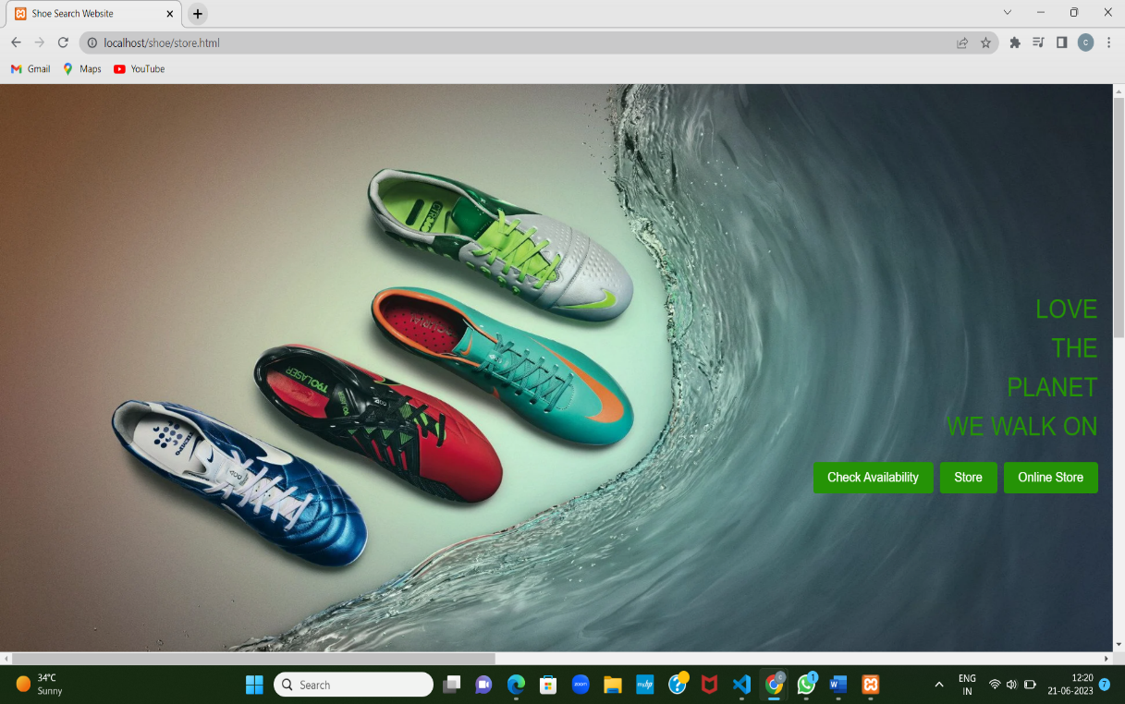

**Fig.1: main page :This web page provides user with options for three web pages which allow users to store retrieve shoe data.**

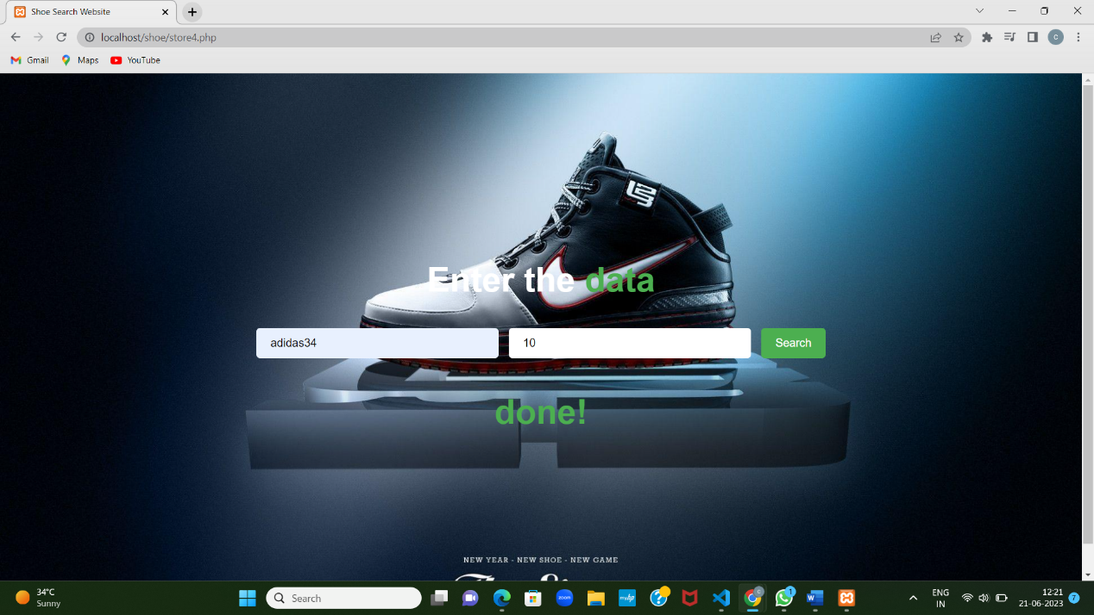

**Fig.2: store page: It allow user to store shoe data**

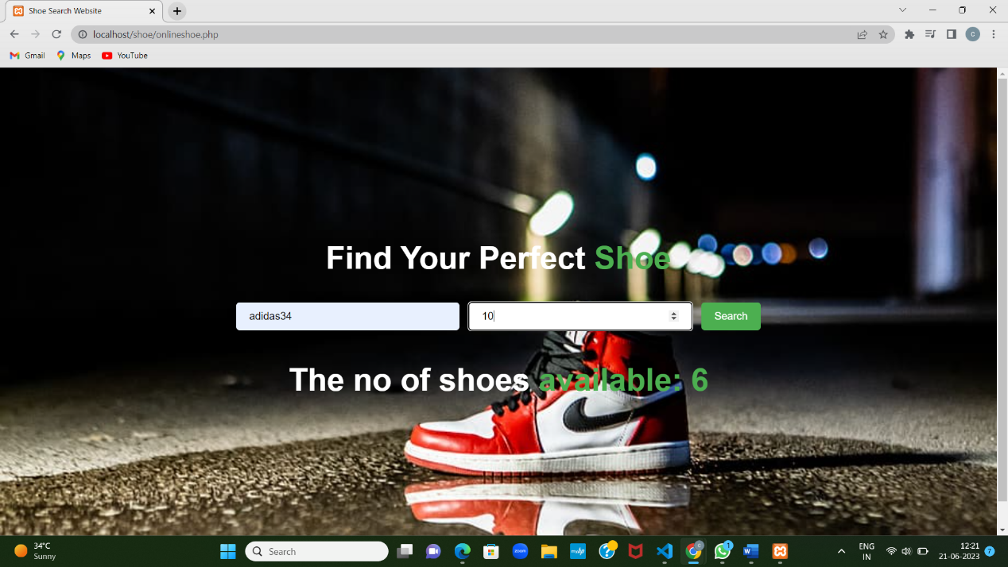

**Fig.3:retrive page: It allow user to retrieve data from data base**

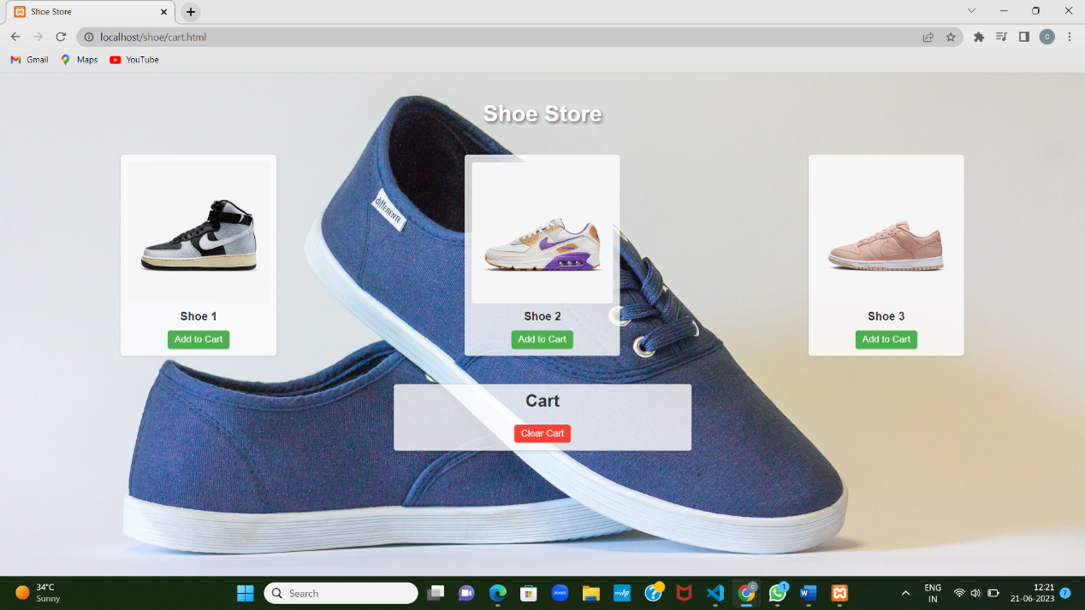

**Fig.4:shoe store: It manages the shoe shopping cart functionality allowing users to add and remove items for purchase.**

***References :***

* **[1]**[**https://www.php.net/manual/php3.php**](https://www.php.net/manual/php3.php)
* **[2]W3 schools**
* **[3]MDN Docs**
* **[4]Stack overflow and geeks for geeks**